[](https://essexwellbeingservice.co.uk/support/carers/)

**Carers & Helpers Noticeboard**

**A central point of contact for support for unpaid carers 0300 303 9988 Phonelines are open Monday to Friday 8am-7pm Saturday 9am-12pm E:** [**provide.essexwellbeing@nhs.net**](mailto:provide.essexwellbeing@nhs.net) **or** [**https://essexwellbeingservice.co.uk/support/carers/**](https://essexwellbeingservice.co.uk/support/carers/)

**West Essex**

**April 2025**

**Carers UK’s** latest *State of Caring* report looks at carers’ mental health and the need for support from social care services. 57% of the carers surveyed said they felt overwhelmed ‘often’ or ‘always’ while 37% felt overwhelmed ‘sometimes’. 73% of carers in employment found it stressful to juggle work and care.

|  |  |
| --- | --- |
| Main reasons carers gave for feeling overwhelmed | % of responses |
| *Not being able to take a break from caring* | 65% |
| *Managing the different needs of the person I care for* | 59% |
| *Struggling with my own health condition* | 50% |
| *Dealing with all the administration involved in caring* | 38% |
| *Not getting enough support from social care services* | 37% |
| *Not getting enough support from family and friends* | 35% |
| *Not getting enough support from GP or hospital staff* | 35% |
| *Struggling to manage financially* | 32% |

The survey found 66% of carers said they needed more support with their health and wellbeing – this is the most commonly reported need.

The authors point out “*Feeling undervalued can have a negative impact on health and wellbeing. 57% of carers said they needed better understanding and recognition of unpaid carers from the general public. Many carers feel they are invisible – that they are caring behind closed doors, and that there isn’t enough recognition of the vital role they are playing in supporting health and social care systems”*. To read the full report go to:

[State of Caring - The impact of caring on carers’ mental health and the need for support from social care services | Carers UK](https://www.carersuk.org/reports/state-of-caring-the-impact-of-caring-on-carers-mental-health-and-the-need-for-support-from-social-care-services/)

[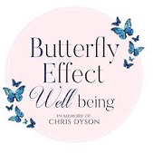](https://www.butterflyeffectwellbeing.com/book-online)offers a variety of sessions to help support carers’ mental health and social isolation at their Wellbeing Hub in Harlow, CM18 7BL. A free weekly relaxation session for carers is held every Thursday as well as social and support groups throughout the week. Other activities available include a weekly Walk & Talk group, gardening group, Arts & Crafts for Mindfulness, Yoga, Gong/Sound Bath, Meditation, Shakti (breathing, movement, meditation) and Shamanic Drumming workshop. Some sessions are held during the evening and at weekends including *Andy’s Man Club* on Monday evenings. A small fee is payable to help the charity offer some activities.

The charity also offers both evening and daytime support groups specifically for people who are bereaved by a loved one’s suicide. Click on the logo above for more information and to book on to any of the above sessions. Or telephone 07760 288 198 or 07359 794 171, or email [admin@butterflyeffectwellbeing.com](mailto:butterflyeffectwellbeing@yahoo.com)

[](https://www.wea.org.uk/courses/life-skills/courses-for-carers)offer free online wellbeing workshops and courses for unpaid carers, former carers and the cared-for. Courses include meditation, Reflexology, Auricular Therapy, Emotional Freedom Techniques, seated yoga, creative writing/art, mindfulness & gardening and baking an Easter decoration. An annual membership fee of £15 is required to access the broad range of courses WEA offers. Membership is free for under 25year olds and for people who are on low income or who receive certain benefits. Click on logo to find out more or call **0300 303 3464**

**[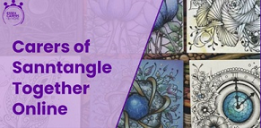](https://www.essexcarersnetwork.co.uk/events/)Essex Carers Network** now host free online *Sanntangle* sessions on the **last Thursday of every month** for family carers of loved ones with a learning disability and/or autism. Sanntangle offers an opportunity to unwind and get creative and requires only a sheet of white paper, a 2B pencil, a black fine liner pen, a rubber and a cotton bud! The next session will be held on Zoom between **6:30-8pm** on **Thursday 24th April**.

In person Sanntangle sessions are also being held at the **Latton Bush Centre** in Harlow, CM18 7BL between **10am – 1pm** on **Wednesday 9th April** and **14th May**. Click on image to find out more about all the support ECN offers and to register for a place on any of these sessions. Or call 07360 689 075 or email [info@essexcarersnetwork.co.uk](mailto:info@essexcarersnetwork.co.uk)

**[A group of hands in a circle
](https://essexwellbeingservice.co.uk/healthcare-professionals/health-checks/#:~:text=Those%20between%2040%20and%2074,diabetes)New** Dunmow Carers Support Group meets on the **first Tuesday of every month** between **10:30am-12pm** at the Rowena Davey Day Centre, Dunmow CM6 1EQ. For anyone needing to bring along their cared-for person there is an adjacent area in the centre where they can sit and enjoy tea/coffee and a piece of cake. The group offers peer-to-peer support plus an opportunity to speak to local providers of services that can support unpaid carers.

EWS are scheduled to attend on **Tuesday 6th May** and will be offering **free NHS Health Checks** to carers and cared-for people who meet the eligibility criteria. The check takes around 20mins and is specifically designed to help identify a person’s risk of stroke, certain types of dementia, type 2 diabetes, heart or kidney disease. For more information about the NHS Health Check and who is eligible click the hand image above. Anyone interested in prebooking themselves a check, or wanting more information about Dunmow’s Support Group, can contact Kinder Essex Coach Christine on 07305 716310 or email [Christine.Chester@ceessex.org.uk](mailto:Christine.Chester@ceessex.org.uk)

[](https://chelmsfordcityracecourse.co.uk/p/71L7-I0C/complimentary-ticket-application-form)are inviting unpaid carers to apply for 2 FREE general admission tickets to enjoy an evening of racing on **Thursday 12th June** with a friend or relative for some well-deserved respite without the person that they care for. This offer applies to people who are providing care for an adult (18+) family member who is dependent on them for the majority of their day to day needs. Click logo for more info and to apply for these tickets before the offer closes on Mon 9th June. Or call 01245 360 300 or email [info@chelmsfordcityracecourse.com](mailto:info@chelmsfordcityracecourse.com)

[](https://www.downs-syndrome.org.uk/our-work/services-projects/training/well-being-wednesday-for-parent-carers/)is a national charity providing a range of services, support, training and information for people of any age with Down’s syndrome as well as their families/ carers.

**Well-Being Wednesday** is a free, online guided meditation/ relaxation exercise session held weekly between 10:30-11am for parents / family carers. Click logo to register and to find out more. DSA also provides a bookable 1-to-1 listening service and their **helpline is open 7 days-a-week** **from 10am to 4pm on** **0333 1212 300**

[](https://www.pactforautism.org.uk/welcome.html)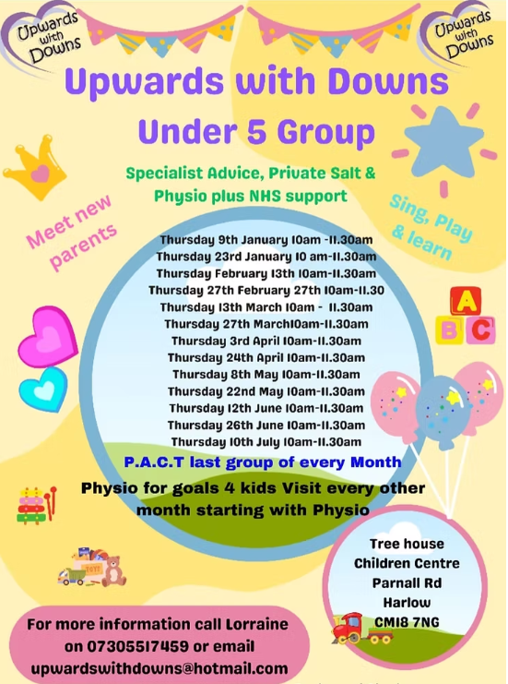

is a Harlow based charity providing information, advice, workshops, activities and socialising opportunities for children, young people and adults with neurodiversity as well as for their parents, families and carers. A formal diagnosis of Autism/ADD/ ADHD is not needed to be able to register and access support from PACT’s team members who all have lived experience.

In conjunction with Families in Focus, PACT are hosting an in-person workshop on *SEN Support and One Planning* at **Harlow Playhouse** on **Thursday 3rd April** from **10:30am -12:30pm**. Tickets costs £3 per person & includes refreshments. Click logo for more information and to register to attend this workshop and any of the following PACT sessions:

|  |  |  |
| --- | --- | --- |
| Monthly sessions for parents / carers | venue | cost |
| **Walk & Talk** wellbeing session | Start & finishing at Spurriers Café Harlow Town Park | Free |
| **Cuppa and Connect** sessions | Epping Hall CM16 5DN  Harlow Playhouse CM20 1LS  Saffron Community Link CB10 1HX  Evening online session on Zoom | Free |
| Monthly sessions for children, young people and adults with neurodiversity | | |
| PACT Neurodiverse family soft play sessions  for children with Autism / ADHD aged 12yrs and under | Wild ‘n’ Wacky Soft Play, Harlow  (siblings under 12yrs also welcome) | £4 per child (includes booking fee) |
| PACT Gaming sessions  for children & young people aged 8-15yrs and aged 16+yrs | Gamers Cage, Quasar Harlow  (siblings aged 8-18yrs also welcome | £3.50 per gamer |
| Art Empower sessions for neurodiverse female, Transgender and Non-binary individuals aged 11-16yrs and 17-25yrs | Hare Street Youth Centre (The Hub)  Harlow | Free  (funded by Essex County Council) |
| Connections online sessions for neurodivergent adults (18+yrs) | Evening online session on Zoom | Free |

[](https://www.kids.org.uk/services/send-family-hub/)is a national charity providing a wide range of services for children and young people with a disability and/or SEND, and their families. It offers free bitesize guides on a wide variety of SEND topics. Plus, regularly hosts online workshops offering information, practical advice and opportunity to ask questions to experienced SEND professionals. Some workshops are free while others charge a fee to attend. Click logo to find out more.

[](https://autismhub.kids.org.uk/)is for young people living in Essex (including Southend and Thurrock) aged 12-25yrs who are either newly diagnosed with autism or are on the diagnosis pathway, and their family members. The online hub offers:

* Bite-size info & videos on understanding autism and coping strategies other young people have used.
* Weekly online groups to ask questions, hear the experiences of other people and for peer support.
* Directory to a range of local autism services who can help with individual needs.

Click logo above for more information and for online referral forms to this service.



Brentwood Care Centre is offering 32 free places to experience the virtual dementia tour bus on **Tuesday 20th May**. This immersive experience provides valuable insights into what it feels like to live with dementia and helps with understanding the daily challenges people with the condition face. Bookings are available on a first come first served basis to either the morning session at **10am-1pm** or the afternoon session at **1:30pm-4:30pm**.

For more information about the experience and to book a place email [Rhiannon.Mcneill@rchcarehomes.co.uk](mailto:Rhiannon.Mcneill@rchcarehomes.co.uk) or call 01277 375316.